Business use cases Baggage Check-in and Baggage Handling extend Check-In use cases, because passenger might have no luggage, so baggage check-in and handling are optional.

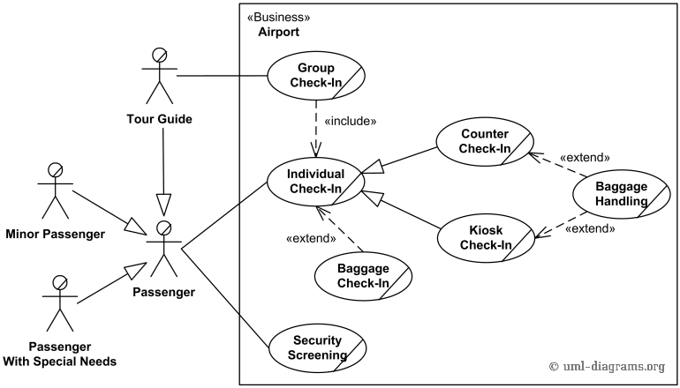

*An example of use case diagram for airport check-in and security screening.*